Case 1-Eur-France-Dordogne-Flint Core and 14 blades- Magdalenean-17,000 BP

## Magdalenian core with 14 blades 17.000 - 12.000 years old

* **Core + blades are found independent from each other, these blades do not necessarily belong to this core but are from the same age and location.**
* Material: Flint stone
* Dating: Neolithic 17.000 - 12.000 years ago
* Size and weight: 14 cm 1.3 kilo (in total).
* **Found:** Dordogne *departement*, France
* From an old Dutch collection
* 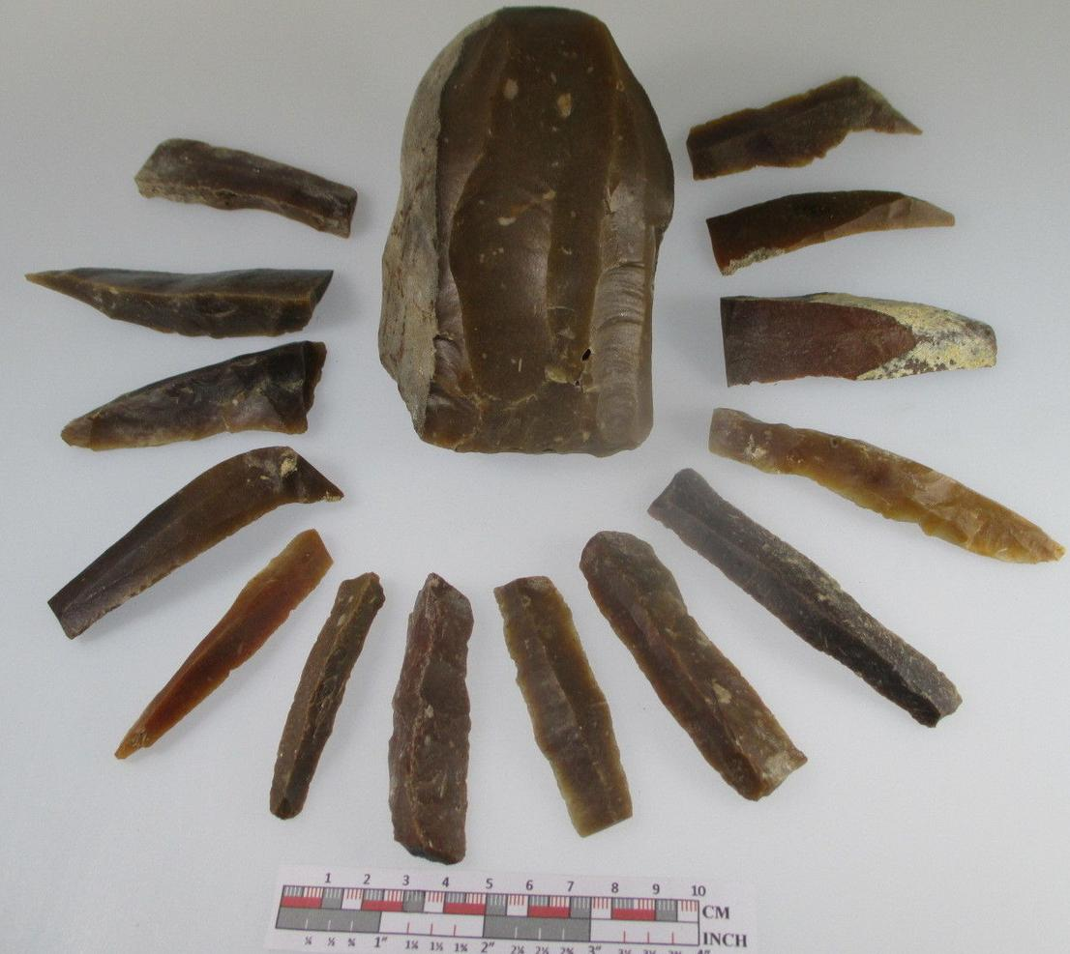

Magdalenian (Magdalénien) 17,000 and 12,000 BP culture of the Upper Paleolithic in western Europe named after the type site of La Madeleine, a rock shelter located in the Vézère valley, commune of Tursac, in the Dordogne *departement* of France. This core and blades were found in the *departement* that the original site was located, adding to their prehistoric importance as being of the earliest Magdalenian periods.

The culture spans the period between ca. 17,000 and 12,000 BP, toward the end of the last ice age. The Magdalenian tool culture is characterized by regular blade industries struck from carinated cores. Typologically, the Magdalenian is divided into six phases which are generally agreed to have chronological significance. The earliest phases are recognized by the varying proportion of blades and specific varieties of scrapers, the middle phases marked by the emergence of a microlithic component (particularly the distinctive denticulated microliths), and the later phases by the presence of uniserial (phase 5) and biserial 'harpoons' (phase 6)

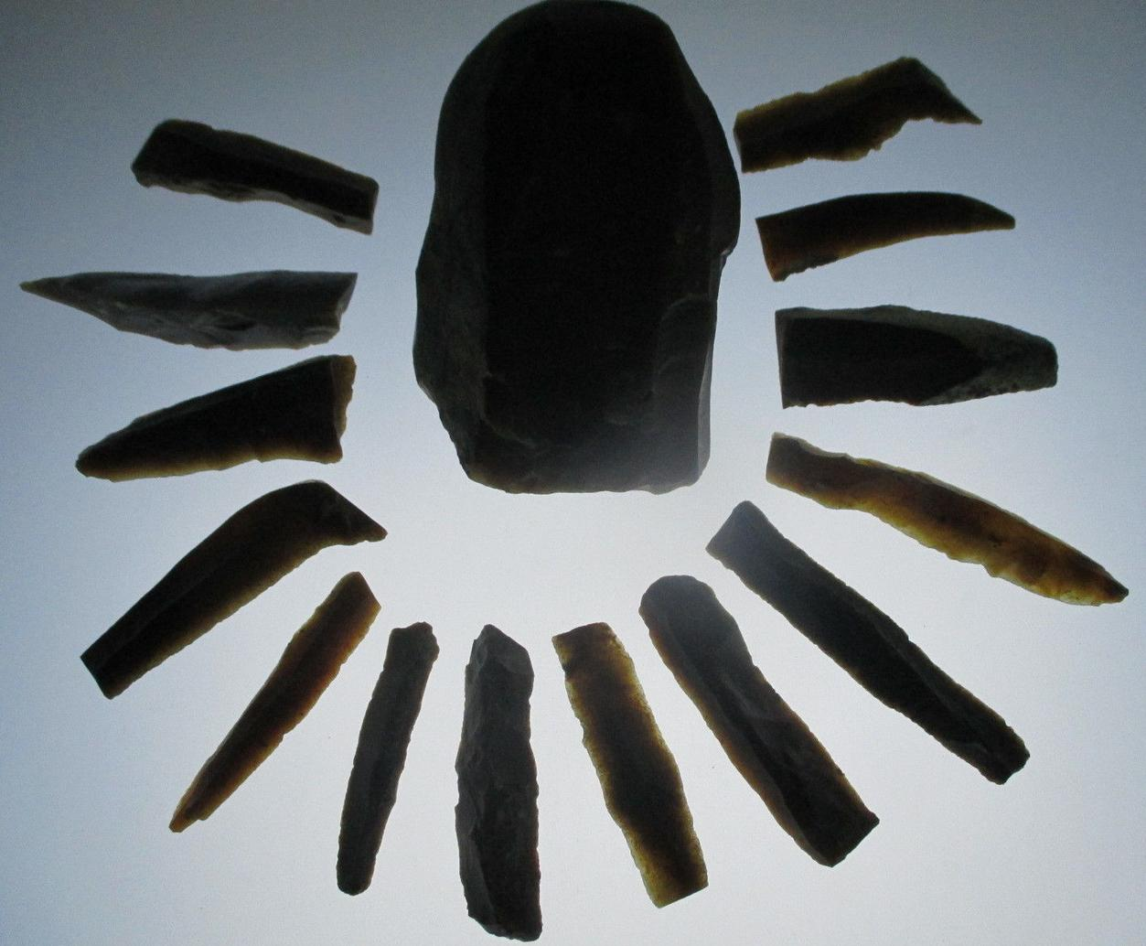 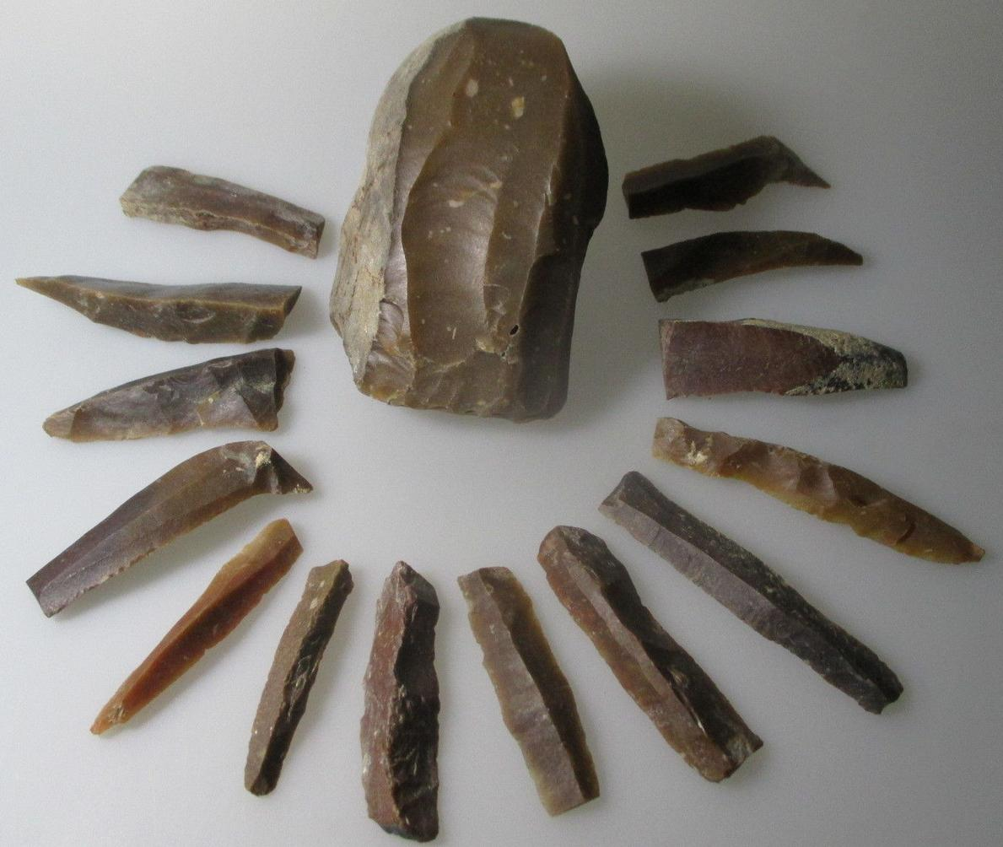 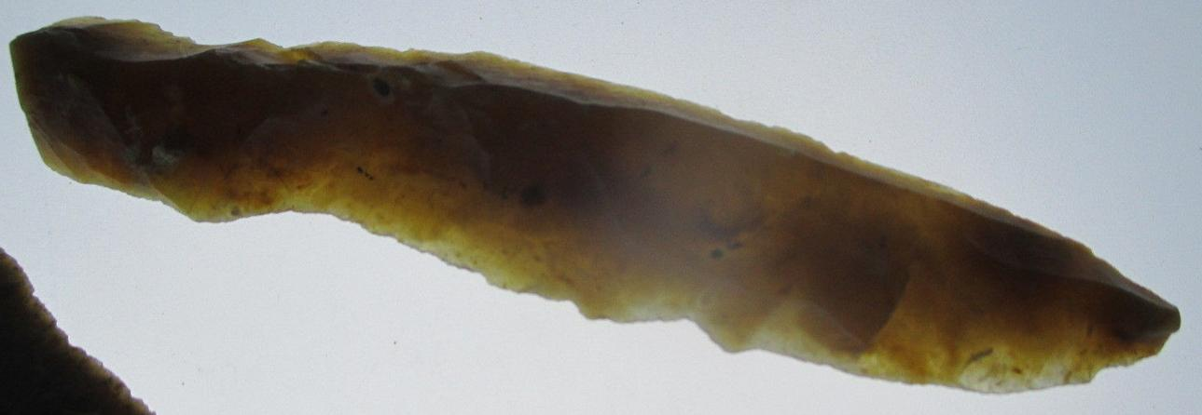

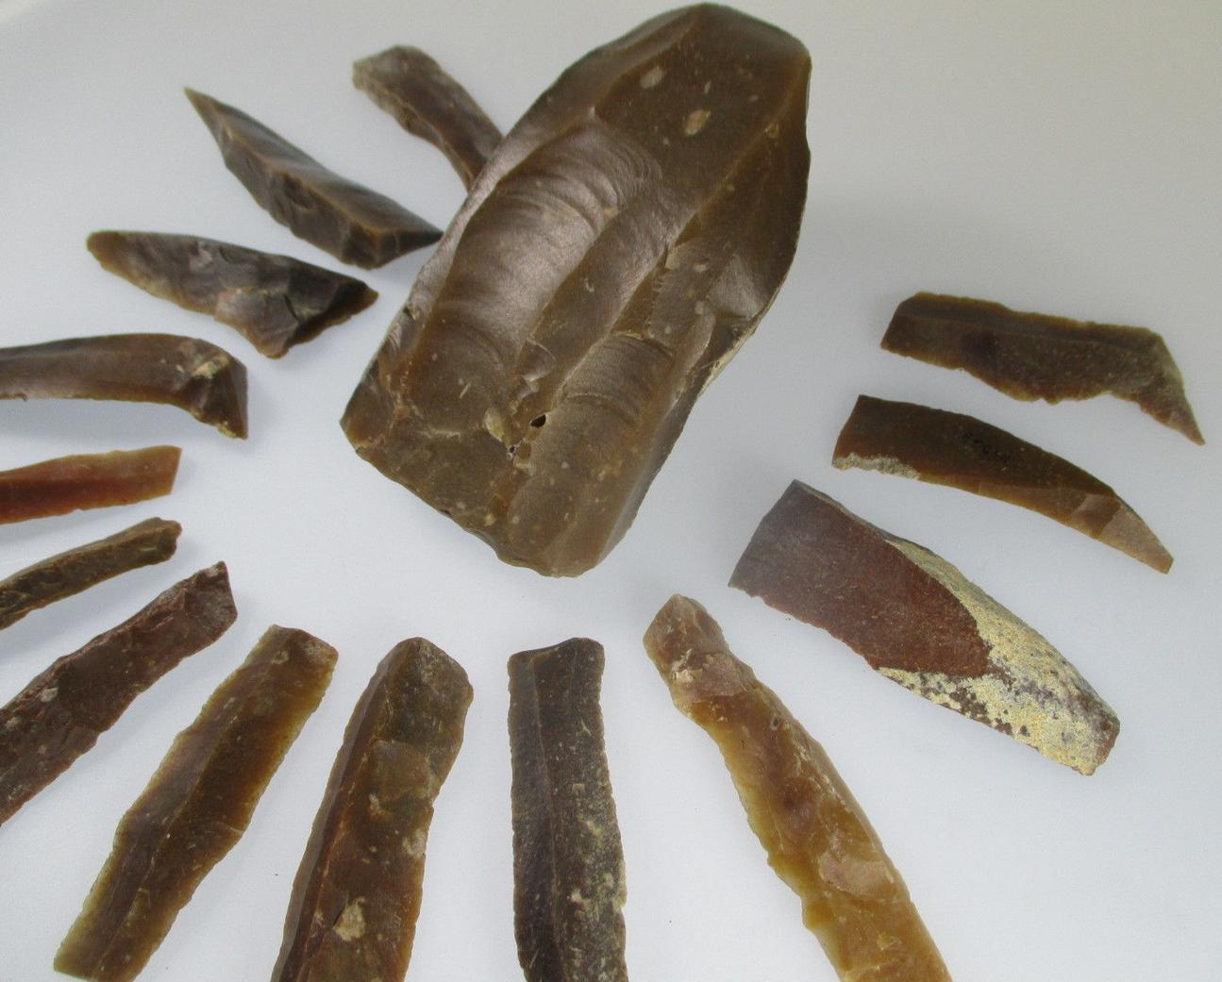 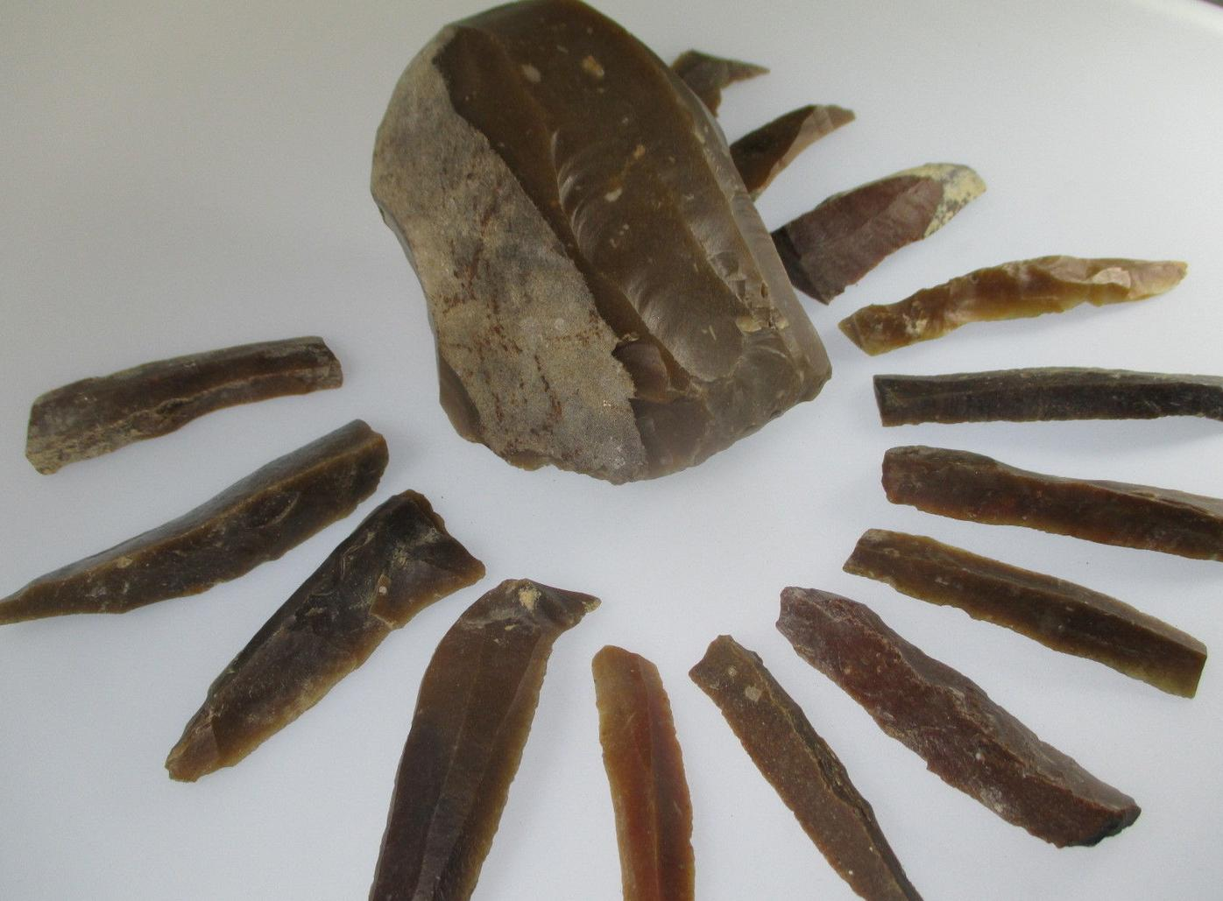

Sold by [mammoet](http://myworld.ebay.com/mammoet) ( [562](http://feedback.ebay.com/ws/eBayISAPI.dll?ViewFeedback&userid=mammoet) )

### Delivery package 1 of 1

No estimate available

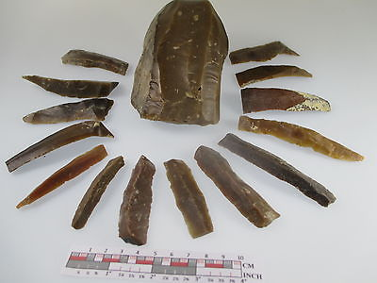

#### [Large Rare Magdalenian flint core with 14 blades France 14 cm 1.3 kilo p521](http://www.ebay.com/itm/262048726486)

|  |  |
| --- | --- |
| Item price | $109.00 |
| Quantity | 1 |
| Item number | 262048726486 |
| Shipping service | Standard Shipping from outside US |